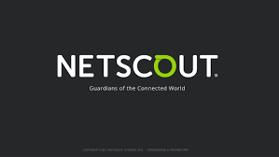

About NetScout:
A leading provider of business assurance – a powerful combination of service assurance, cyber security, and business intelligence solutions – for today’s most demanding service provider, enterprise and government networks. NETSCOUT’s Adaptive Service Intelligence (ASI) technology continuously monitors the service delivery environment to identify performance issues and provides insight into network-based security threats, helping teams to quickly resolve issues that can cause business disruptions or impact user experience. NETSCOUT delivers unmatched service visibility and protects the digital infrastructure that supports our connected world.

Specialties: Business Assurance, Digital Transformation, IoT, Unified Communications, Virtualization, Network Infrastructure Optimization

Website
http://www.netscout.com

Software / Senior Software Engineer
Experience: 5 - 8 yrs
Must Have Skills:
- Strong knowledge of Java Script/JSP/Ajax
- HTML5/CSS/XML handling in Web Applications
- Hands-on experience on client frameworks such as Angular, Ember etc.
- Familiarity with Web servers (tomcat & Apache)

Desired Skills:
- Experience on Java server side, data structures, algorithms and databases.
- Good understanding of OS concepts, Networking concepts. Network programming in Java for distributed, multi-tier, client-server systems

Soft Skills:
- Excellent teamwork
- People with very good communication skills and attitude is a MUST

Location: 7th Floor, Bajaj Brandview, Old Pune-Mumbai Road, Wakadewadi, Shivajinagar, Pune,

